Bulletin 14 of Information Center of Indigenous Peoples of Altai Republic ''Birlik''

Tuba
After reading the published works of researchers of Gorny Altai concerning the Northern Altaians’ way of life we must note the significance of these studies to modern science. After all people's memory would be unable to convey details of past times to the present day. However it should be noted that many studies make mistakes and distortions in names. In P.E. Tadyev‘s scientific article "Ethnic composition of pre-revolutionary Altaians and peculiarities of their administrative arrangement" in the chapter on" Ethnic composition and dispersion of tribes of Gorny Altai" the author, referring to prominent researchers of the 19th century, complains that" none of them, taken separately, give us information on ethnic composition of tribes of Gorny Altai". In my opinion, when you have the appropriate education and belong to the Altai people it is easier to explore this very question yourself, the more so because there has been no change in ethnic composition of tribes of Gorny Altai in the last 100 years. It seems that the distortions and errors in the history of Gorny Altai are transferred from one scientific works to the other.
Let us consider the term "Tuba" which is the ancient name and is known from the Chinese dynastic chronicles in the form of "Dubo", but none of the source say that the original name of that ethnic group is "Tuva". Our people were listed in the Single List of Indigenous Peoples of the Russian Federation as Tubalars. In all dialects of Altai language affix "lar" indicates the plural form. It is added directly to the name, for example, Altai – Altailar (Altaians), Tuba - Tubalars in Altaian dialect, Tuva - Tuvalar in tuba dialect.
We can agree with the term "Tuba" (but not "Tuva") because we have no writing in our dialect, but the fact that the affix "lar" together with the term "Tuba" moved from Altaian language to Russian is a curious incident. For example, we say Altaians but not Altailarians. And so we figure in history as Tubalars and not as Tuba. The Kyrgyz, for example, in due time managed to prove that they are not Kirghiz. The term "Tuba" is probably not declined.
Let us return to the article of P.E. Tadyev where he describes what tribes Tuba consisted of. It should be mentioned that there are incredible distortions in names of tribes.
V.I. Verbitsky in his book "Altai Aliens" described names of months in dialect of Northern Altaians. There are distortions in sequence. I wrote down names of months in tuba dialect according to my parents’ words.

January - shchin ai (true month)
February - toonok ai (snow mounds)
March - ktsryk ai (chipmunk came out)
April – naus
May - tya shchavan ai (sow wheat)
June - odo ai (weeding)
July - tidu tyaylyu ai
August - ulu ai (senior month)
September - sygyn ai (month of maral)
October - shchana ai (prepare skis for hunting)
November - ulu kyrlashch (elder)
December - kizhyu kyrlashch (junior)

Although Tubalars, Chelkans and Kumandins got the status of indigenous peoples of Russia it only slightly changed their state. They have a right to protect their interests, but they cannot always take advantage of this right because many vital issues are not clarified in the Constitution of the Russian Federation and federal law.

Zinaida Bakasheva

Balykcha
How long can one read about solvable and unsolvable problems? There were plenty of them in the time of stagnation and now they are everywhere.
I just want to write about my native land Balykcha.
My village is located in the picturesque Chelushman Valley; it is surrounded by high rocky mountains on the bank of the Chelushman River. Balykcha is 130 km far from the district center Ulagan and 10 km far from the Teletskoye Lake.
At the beginning of last century there was no place of compact residence there. There were tribes (clans) from Bele to Katu-Yaryk.
My father's parents lived in Kokpash Village which was between Balykcha and Koo Villages. My mother was born in Balykcha.
Before revolution missionaries came and baptized telengits, built a monastery in Kaira Village and an orthodox church in Ala-Kaiyn. In the twenties there was a commune "Free Labor" (Russian) but none of the locals wanted to join the commune. Communards sowed crops, hayed and built houses. Then suddenly the White Guards came from Ulagan at night and killed all the communards. There is a monument on their common grave.
In Kairu with the advent of Soviet power a school was opened in the building of the monastery and a boarding school for children from the whole valley. Kairu is beyond the Chelushman River. Children were transported by boat across the river. During the collectivization the Thalmann farm was found in Balykcha and the Lenin kolkhoz was found in Kokpash Village.
The Lenin Kolkhoz was the farm with a million a year. But in early fifties they decided to merge those two farms into one large one. Balykcha became a farm centre because the school and the boarding school were near, beyond the river.
In the early sixties the school and all its extensions were relocated into Balykcha. The school was an eight-year one until 1975; children had to finish school in Ulagan. In 1975 the school became a secondary one. Now we have a new, beautiful school; about 200 children go to it. There is a modern gym and a computer class there. The teaching staff consists of locals. There is a boarding school where children from the nearby villages and stands may live. After school our children enter universities in our city as well as beyond the bounds of our republic.
There is an orthodox church in the village; the majority of villagers are baptized. Everyone observes Christian holidays and keeps fasts. Weddings are conducted according to Russian customs although matchmaking is held by Altaian tradition. Everyone knows the other’s tribe.
People raise livestock, hunt and fish as before. Each yard has its own garden and orchard.
We have our own hydroelectric power station on the waterfall in Kairu; electricity is generated day and night. And still we cannot do without the word "problem". We have problems with firewood and a bad road.
But despite all the difficulties we live, work, raise children and look forward to all the best in the future.

Nadezhda Bydysheva

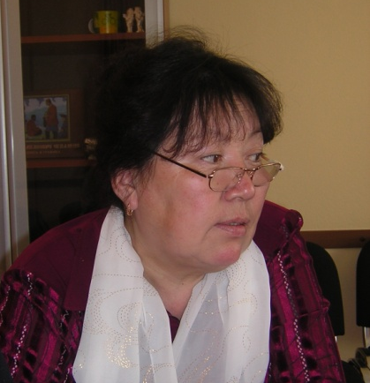

Big problems of small people
Altai is unique, and the status of UNESCO World Heritage Site has proven natural values of Altai. Its cultural heritage is of equal importance. In essence the land, history, traditions and culture are a single whole. People of different nationalities, including Kumandins, live on the territory of Altai Republic. Kumandins of Altai Republic belong to Turkic small-numbered peoples, they are 3000 in number. Kumandins’ mortality exceeds fertility, the reasons are unemployment, alcoholism, drug addiction, homelessness. Investigation of the Institute of Cytology and Genetics, Siberian Branch of the Russian Academy of Sciences and the Institute of the Problems of the Minority Peoples of the North SB RAS, revealed that indigenous peoples of our region are on the verge of losing of gene pool, language, culture, i.e. on the eve of extinction!
Taking into account what is going on in the world community and reforms in the country, a law "to guarantee the rights of indigenous peoples" was passed at federal level. In this connection, practical steps to preserve culture of small-numbered indigenous peoples that administrative bodies and first of all bearers of these cultures have taken recently seem to be quite logical. These efforts should be welcomed and supported. One of the positive samples of such recourse to the origins of native culture is "Kumandin Dictionary" written by L.M. Tukmachakov. The author is a great expert on the language, customs and history of his people. He is the author of a number of books about language and ethnography of Kumandy-Kizhi (in particular "Kumandin - Russian Dictionary", Biysk 1995).
His primer "Kumandang" is quite a logical and timely step of a researcher and teacher who cares for the fate of his people and unique culture. In view of all these problems of small-numbered indigenous peoples establishment of such a center is necessary.
On the basis of the cultural center we plan in the long term to create an ungraded Sunday school for learning native language, folklore, rituals; establishment of a library with collection of textbooks and fiction, establishment of a computer class, arrangement of exhibitions of collection of household stuff, articles of culture, photo exhibitions.
The main aim of the cultural center is working with the younger generation, students, young professionals who are in need of labor market.

Pavel Polushkin

Who is the owner of the land?
Urlu-Aspak Village is situated on the territory of Maima District of Altai Republic on the banks of the confluence of small rivers Maymushka and Kuyumka. According to the 2002 census the number of villagers is about four hundred people, most of them are young people. Old residents can be counted on the fingers of one hand. A school, a first-aid post, shops and a village hall are the social objects. And if we talk about Maima, the regional center of Miama District, it is considered to be most populated in Altai Republic. According to statistics its population size is higher than in such European countries as San Marino and Monaco. Our village Urlu-Aspak (translated into Russian as dry aspen) is a beautiful place. It is surrounded by not very high mountains of very beautiful shape. The village is surrounded by dense coniferous forests. There is a large number of medicinal plants, including mountain garlic, ramsons and fern. Visitors are attracted and bewitched by pure, crystal air of mountain peaks, serene, and pleasant to the eye nature: tall, slender birches, sunny pines, evergreen cedars, bright flowers. There are many springs flowing into the River Maymushka, they have medicinal properties and are known as Arzhan-suu. My village is a place where you can relax in the quiet of forest listening to the singing of birds. My land is generous, kind and beautiful!
The past years and real life of the village show that despite the complexity of the political, economic and social reforms in the country, accompanied by rises and crises, we, the residents of the village - Tubalars, Russians, Chelkans, Kumandins, managed to survive and preserve spiritual and moral values. As small-numbered indigenous people we competently participate in various mass activities of our republic, district and village to protect the legal rights of small-numbered indigenous peoples. The residents of Urlu-Aspak are mainly Tubalars. It must be admitted that we, Tubalars, have problems and difficulties that can be solved only by knowing the rights of indigenous peoples. Tubalars have always been people of taiga, forests and mountains. It is very important for us to preserve integrity, traditional way of life, language and our territories not only for us but also for our descendants.
Prior to perestroika the main activities of Tubalars were animal husbandry and farming. Everyone was engaged in reindeer breeding and in subsequent years in maral breeding. Hunting, bee keeping and vegetable growing played an important role. They also gathered medicinal herbs, roots, pine nuts and used timber by-products. At present my people suffer from chronic unemployment. Degradation of agriculture has led to poverty, alcoholism, life shortening of a rural dweller. Today decline in jobs continues everywhere in traditional branches of agriculture, this leads to additional increase in the unemployment rate. In fact people are dependants of their family members: pensioners, disabled persons and recipients of survivor benefits. Employable population lives on the verge of poverty. There are no jobs for college, technical secondary schools and specialized schools graduates. In other words there is no way for young professionals. For the sustainable development of indigenous peoples it is necessary to enhance and preserve the spiritual heritage. But for my people, Tubalars, the first major problem is preservation and development of language. I think ignorance of language is the first symptom of possible extinction of the people as a whole. Such a phenomenon will not be noticeable on a republican scale. After all the second official language in the Altai Republic is Altaian. Even in schools they mainly teach Altaian language. In Maima District pupils study native language only in 2 schools of 16 ones. Language of Tubalars has been disappearing for several decades. There are no applications to textbooks of Altaian language for teaching in schools. Tubalar language is different from Altaian in its dialect. Many words, for example, are similar to Khakass language. And now, only a few decades later, young people no longer speak their mother tongue. Older people who are few in the village rarely speak their native language either. They prefer Russian language which has remained fashionable since post-Soviet times. Traditions and customs of our people are forgotten. Where now you can see the elementary traditional rules of conduct for elders and youngs in the family? Almost nowhere. We thou both elders and youngs.
Today the first issue for Tubalars is preservation of traditional territory of residence and their natural resources. Tuba-Kizhi used to be engaged in livestock raising, fishing, hunting, and gathering medicinal plants. According to the stories of my grandfather there even was an oral economic calendar connected with hunting. Our Maima District is one of tourist attractions in Altai Republic. The tourist industry is developing very actively. And our small village is not the exception. But what are the pros and cons? The clash of two civilizations, mentalities, incompatible mores with respect to the world is inevitable. Tubalars who live here from everlasting and carry on their traditional life connected with nature lose everything even their lands. Development of tourism, commerce and business reduce the villagers to beggary. No one can be certain about what will happen in the near future. Whose land our children, Tubalars, will live on. The population of Urlu-Aspak Village already lives between a "barbed" wire and a green-painted high fence. This is apparently a symbol of the coming of "civilization" which warns that the local population is being alienated. Who will put us up to it and will help restore the rights of indigenous peoples? It is we who must defend the interests of people. A people without land is not a people. Great wars in the history of the world were caused by a plot of land. And we see how we lose everything but we watch silently all this and nod our heads. We sold everything for money. What we will leave to our descendants? In this difficult situation we should use all possible means. One of them, for example, is establishment of territory or family community. We must explore more human rights instruments related to indigenous people, use them and teach the younger generation to protect the legitimate interests of the people. A joint activity of public organizations and local government provides many opportunities of problem solving. Activity of local residents also plays an important role. We, as owners of our land, should take care of it and protect it.
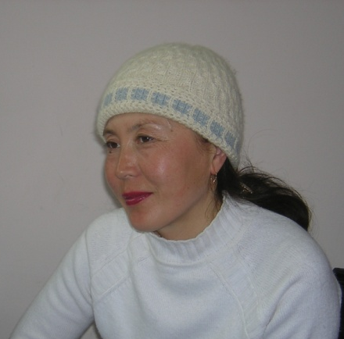
Irina Vanjusheva

Richness of Altai. Its sources
Every nation has its own traditions and customs, because if the language, traditions and culture of a nation is living than it is living itself.
And every nation has its own language, traditions and culture. They are unique and diverse.
Turkic and Mongolian peoples have long practiced treatment with healing springs Arzhan-Suu. As is known, the territory of Altai Republic is very rich in such springs. The healing properties of these natural springs in people conception are understood by religious-philosophical systems of nature worship. Telengits’ usage or knowledge about the healing properties of arzhans is closely linked with the rituals in religious practices.
Recently due to the fact that we have rapidly developing tourism in the republic, with arrival to our sacred land of people unaware of customs and traditions of its indigenous inhabitants - telengits, our sources more and more run the danger of extinction and pollution. And unfortunately no one pays attention to this issue.
Telengits pray to arzhans twice a year: in June - July (this time is called - agash d’azharza), and in August - September (agash-buri sargaza), and each praying is accompanied by certain rituals. Before we make first sips we must tie d’alama (divine ribbon) to the spring. They are tied to trees near the spring, and only then they drink water from it. If there is no such ribbon, then they put buttons, coins (copper is not allowed) in arzhan. D’alama should be white, blue, yellow, and should not exceed the width of one finger. Telengits say that broad ribbons cause discontent of the master of Altai.
It is prohibited to soap, throw garbage, scream and laugh loud by arzhans. They say that the master of arzhan (Eezi) watch over all these violations.
Unfortunately, our healing springs became places where you can just relax and have fun for tourists and other people. We do not ask them to perform our rites, bow to our sacred mountains, etc., we just want to say that owing to these customs and traditions our ancestors preserved their land and nature for us, and we want to preserve them for our children and grandchildren. This, unfortunately, depends not only on residents of Altai Republic but also on visitors.
Konstantin Tadyrov

And about tourism again
In Altai Mountains it is possible to organize various types of recreation and tourism activities at all seasons (summer, winter, spring and autumn): road, water, air (by helicopters), backpacking, horse-riding and combined forms; health, sport, business, scientific, educational, environmental, historical and cultural and ethnic tourism and their combinations. Natural resources (variety of landscapes, pure mountain air, plenty of rivers, lakes and waterfalls, karst caves and mountain-valley glaciers, mountain peaks and passes, biodiversity, multicolored gems and minerals, state parks and reserves , Ukok Quiet Zone ) as well as cultural and historical sights (historical sites and archeological monuments, ancient kurgans and burial grounds, petroglyphs and rock carvings, stone images, sculptures, obelisks, museums), ethno-cultural characteristics of the region (Altaians, Kazakhs, Russians and other nationalities) and specific character of agro-industrial complex promote and favor it. In one of his speeches the head of Altai Republic and Chairman of the Government A.V. Berdnikov express an idea on agro-tourism in the region.
In spring tourism can be combined with gathering of ramson and bracken. In summer there are wild and garden berries - raspberries, currants, gooseberries, black chokeberry, strawberries, blueberries, in autumn - apples, pears, cherries, plums, sea-buckthorn, wild cherry, arrowwood, cranberry, mountain ash, and mushrooms. Since May they begin to gather honey (May honey). The great ancient Greek physician Hippocrates recommended honey for many diseases. And no less great healer Avicenna said: "If you want to stay young be sure to eat honey." Beekeeping is developed everywhere except perhaps high mountains.
The most physically developed tourists can gather pine nuts, hay and make other farm work. They may fish during the whole frost-free season. These types of recreational activities are for pleasure.
Recreation proper is air, sun and water baths supplemented with antlers bath, antlers water in June where they can raw antlers of maral stags and deer. Maral breeding is in eight municipalities of republic out of ten, i.e. everywhere.
Healing goat's milk, koumiss, buckwheat honey, acacia honey, motley grass honey, lamb and goat meat shish kebab, rich national cuisine (chegen, cheese (aarchy, kurut), byshtak, talkan, kocho, flavoured green tea with talkan and cream, oromo, d’oorgom, karty, araka, etc.) will decorate dining table of guests.
We should always and everywhere assign primary importance to environment, it should be cross-cutting red line which must pass through our hearts, minds, permeate our actions, activities and be noted in oral and written presentations. We need to encourage, educate tourists, vacationers and the local population to high ecological culture. When producing and consuming ecologically clean production, visiting beautiful landscapes, making up picnics and night’s lodgings on the bank of rivers and lakes, in pine forests under the shade of trees, in the field people should be thankful consumers of cultural and recreational resources, not turn recreational facilities in landfills, piles of glass, metal and plastic cans, bottles, bags and other containers.
In this context one automatically put a question what does the Ministry of Natural Resources and Environment do when round timber is being stolen and exported. Ramson, bracken are also being uncontrollably exterminated by "foreigners". The land is being sold to God knows who, fur-bearing animals are being destroyed, including those enlisted in Red Book, even using helicopters and combat rifles. Folk holidays are dedicated to “heroes” of illegal, injurious, barbaric, antistate, antinational, immoral hunting. In Turochak, for example, they dedicated St. John's Day to Mr. Vyalkov, that is they canonized him. And there is no response from the relevant ministry. Now there is a rich harvest of pine nuts coming. And again "aliens" will buy it for a song from simple-minded Tubalars, Chelkans and Kumandins, export it from republic and line their own pockets, and the poor foreigners will remain in their own interest as the hero of the famous poem "Tuba" by L.V. Kokyshev.
And what is happening with the environment? The banks of rivers, lakes and springs are cluttered up. After tourists there are mountains of cans, bottles, rags, and miscellaneous litter. There is no rational and effective nature management and least organization of protection, conservation and transformation of nature. What does inflated staff with ministerial salaries do? Does this management answer its high and important purpose in nature management and environmental protection?

Vera Chibiyekova
Aiana Makosheva
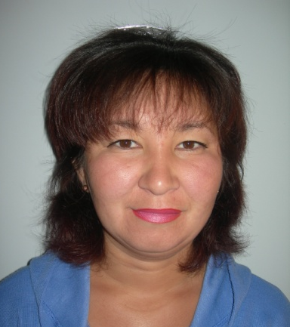

Memories of childhood
I often stayed with my tainashke (maternal grandmother) Efrosinya Petrovna Bekichekova when a child. And she lives near the famous Teletskoye Lake in Kebezen village, Turochak District. She is very hardworking man with a hard life. I remember from childhood she is always in motion. She was either busy with the cattle or in the garden with beds, she loved to go pick up mushrooms and berries in the woods. In winter she always had jam, dried cherry, dried herbs, cranberry preserved. I liked to eat cranberries in winter when the berry is frozen and not sour. She ceased to hay when she was over 60. I liked watching as she stewed cranberries, pumpkin or sifted the same cranberries.
Once I came to my grandmother and asked why she stopped making talkan (barley toasted and reduced to powder) lately. She said that there were no mills in the village anymore and its cooking is time-taking. Several times I participated in preparation of this simple but labor-intensive product. I want to say that this product is very popular with all indigenous peoples of Altai Republic as well as with Turkic speaking peoples. The real talkan is only that one which is made from barley. In the house where tainashka now lives there is no chadyr (summer national housing), so the talkan cooking process began under a canopy where the hearth (fireplace) is.
Tainashka took an old cauldron, warmed it up and added small portions of barley continuously mixing it with a long stick with either fabric or wool at the end. She roasted the barley until the grain began cracking, its shells burst, and barley started to colour. Tainashka aired roasted barley, poured it into a bucket and we went to the mill.
We milled roasted barley grain on a handmill which consisted of two millstones. There was a hole on the upper stone in which the stick fixed on the ceiling of the shed was inserted. Tainashka took my hand in hers and we spun the mill. Of course I quickly got tired so I just sat and watched as she artfully ground grain into dust. Then we poured talkan into the same bucket and went home. At home she carefully poured talkan into dense bags and hung them in the pantry. The thing I liked was talkan with milk without salt and butter as it is accepted. Talkan is a very nutritious product; it retains its useful properties for a long time. It is a product of nomads. It does not take much time to prepare.
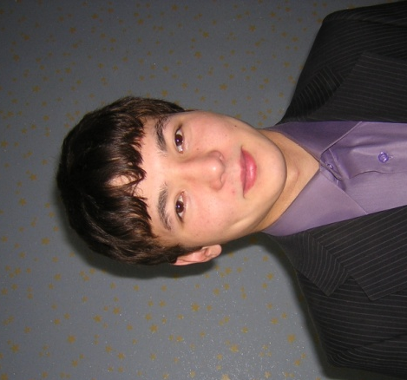
Vjacheslav Seulekov

About Altai and people living here
For centuries our beautiful Altai is famous for its beauty and mystery and attracted new people. Blue sky and evergreen forests, majestic mountains knowing their beauty proudly conquer new hearts. Great writers and artists found new words and colors to convey the delight of soul. And it is not surprising that in Altai there are a lot of talented people, every second paints or composes beautiful poems. When a man is surrounded by such beauty he cannot remain indifferent. Indigenous peoples of Altai honoring the spirits of mountings preserved nature in such good form. In the minds of every human being there is a thought that all this is the God's gift and that we must live in harmony with it. That is why philosophy of Altaians aims to preservation rather than extermination. Every resident knows that he will be punished for mistreatment of nature.
I was very touched by the story of an old hunter. There it is. My friend and I grew together from childhood. We played a game of hunters and grew up in the forest. One day my friend and his father hunted and killed a deer. On their way back they saw a roe and the son wanted to shoot, but his father looked affectionately at his son and stopped him saying very wise words: "Master of mountains was so generous that he gave us a deer, but you still want to take away his roe?" Would you give your relatives so generously?" I have not found an answer to this question and I was very surprised to learn that all animals are children of the Master of a mountain. After that when I went hunting and tied a ribbon on a tree I asked the catch for my relatives and fellow villagers and always tried to share with everyone.
And my friend was a real hunter, everyone respected him in the village, and he spent all his free time in the forest. Some old people condemned him for excessive extermination of animals and he answered that God loved and indulged him. One year he was very lucky, he said that he never returned without the catch, and everyone said that it was a bad omen. His elder brother died before a year was over. Seven days after the funeral his sons and relatives and he went hunting again. This act surprised all the villagers as it is the custom not to go hunting or participate in ceremonies after funeral of one’s relatives. When he was waiting for maral at dawn he saw a large stag and fired. He rejoiced at luck, went for the prey and was surprised as instead of maral there lay his younger son. After that the boy lay bedridden for a long time and emitted sounds like the cry of maral.
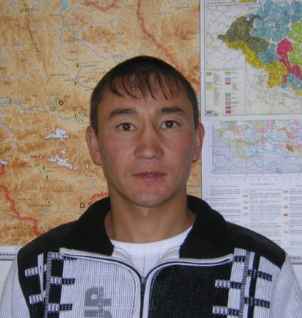
Vladimir Kyzaev

Altai is my native land
Altai is my native land. They call it holy and blue, mountain and gold land.
Surrounding nature has always been alive for local residents. Each spring, mountains, lakes, rivers have their own spirit or, as they say, master. They see it as a young girl, a woman or even a gray-haired old man. Either a hunter or a traveler if caught on the road treated the master with arachka and asked permission to stay overnight. A man felt like a guest and had the kindness to the Master-Nature.
And there is such a sounding and beauty in titles: Golden Lake - Altyn Kyol, Altyn-Tuu - Golden Mountain, Biy - Master in love with the beautiful Katun - Lady. So our people were characterized by aesthetic perception and their own world views.
Legends about the origin of each clan (seok) are extant. My grandfather told me a legend about the origin of people of the "sanmay toys" clan.
Origin of sanmay toys clan (seok)
One person of the kara toys clan adopted an orphan boy but he also had his own son. Once he called his sons and said: "From now on you, my eldest son, will initiate kara toys clan, and you, my stepson, will initiate sary toys or sanmay toys clan." That was the way that orphan boy initiated sanmay toys seok.
From my grandmother I learned the legend about the origin of komnosh clan (Seok).
Komnosh (komdosh) seok
A young hunter wondered in the forest in search of prey and he met a girl in the grove among slender aspens. They talked and he decided to marry her. He brought her home and they began to live together. The days ensued and she bore him a son. Then the hunter’s mother molested him and said: "Oh, balam, it seems to me that you married not a simple girl but a daughter of forest owner Alvyn. She does not sit down to table with us, nobody saw her eating and she wears clothes with long sleeves to hide her nails."
And she advised him to follow his wife. He pretended to be asleep at night while his wife quietly got out of bed and went out the door, he followed her. He saw she took her hair at the crown and uncovered the head, put in food, then shut and covered her head with a kerchief.
The next day he told everything to his mother and they began to think how to get rid of the daughter of forest owner Alvyn and save the child. And his mother told him: "Get up tomorrow morning at dawn, go out into the street and shout:" Your parents' house is on fire!" The hunter got up early, went out into the street and roared: "Your parents' house is on fire!" His wife ran out, looked to the east, hiked her left breast up on her left shoulder and the right breast on the right shoulder, flew into the woods and never came back. And that boy, the son of the hunter and the daughter of the forest owner, initiated komnosh (komdosh) seok.
Such beautiful and mysterious legends were passed on from one generation to another from time immemorial.
Tamilla Alieva

