TRAINIGN COURSE
«EDUCATION IN THE FIELD OF HUMAN RIGHTS AND RIGHTS OF INDIGENOUS PEOPLES»

(16 March – 03 April 2009, Krasnoyarsk)

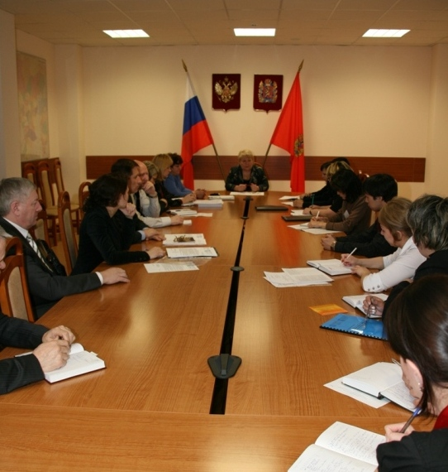

Another training course “Education in the Field of Human Rights and Rights of Indigenous Peoples” took place on 16 March – 03 April, 2009 in Krasnoyarsk Center.
The following representatives of Krasnoyarsk Krai indigenous peoples took part in it:
- Botulu Tatyana, Yessei Settlement, Evenki Municipal Area, Yessei Yakut. Chairman of the family indigenous community “D’ulur”;
- Kaplina Vera, Tura Settlement, Evenki Municipal Area, Evenk. Methodologist of the Ethnic Teacher Further Training Center;
- Kondiyakov Sergey, Pasechnoye Village, Tyukhtet District, Chulym. Founder of the indigenous community “Chulym”;
- Kondiyakova Yuliya, Pasechnoye Village, Tyukhtet District, Chulym. Member of the indigenous community “Chulym”;
- Krivonogova Lidiya, Krasnoyarsk, Khakass. Private tutor, member of the social organization “Trezvaya Sibir” (“Sober Siberia”);
- Osogostok Aleksander, Yessei Settlement, Evenki Municipal Area, Yessei Yakut. Member of the family community of small-numbered indigenous peoples of the North “Kotui”;
- Siguney Anzhelika, Dudinka, Taymyr Dolgan-Nenets Municipal Area, Nenets. Teacher of the Dudinka special correctional boarding school;
- Sutlin Roman, Verkhneimbatsk Settlement, Turukhansk District, Selkup. Student of V. Surikov Krasnoyarsk Art School.
Interns studied the extensive legal block of knowledge and had important meetings.

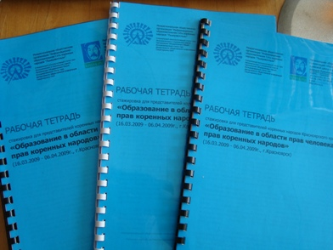 | Interns studied international, federal and krai legislation and local legal acts concerning rights of indigenous peoples. Interns suggested amending the Original Habitat and Traditional Living of Krasnoyarsk Krai’s Indigenous Peoples Protection Act and the Concept of Sustainable Development of Krasnoyarsk Krai’s Indigenous Peoples.  Their suggestions were addressed to the North and Support of Indigenous Peoples Agency of Krasnoyarsk Krai and North and Indigenous Peoples Standing Committee of Legislative Assembly of Krasnoyarsk Krai.

Interns acquainted with the Original Habitat, Traditional Living and Traditional Nature Management of the Russian Federation’s Small-Numbered Indigenous Peoples Bill and discussed its content. Adoption of the Concept of Sustainable Development of Small-Numbered Peoples of the North, Siberia and the Far East of the Russian Federation (adopted by Government Order № 132-р, 04 February, 2009) aroused interest.

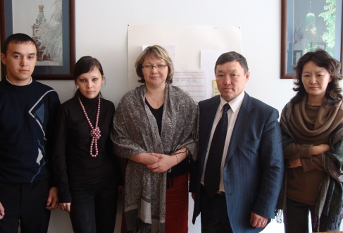 | The training course participants met with Semyon Palchin, Commissioner for the Rights of Small-Numbered Indigenous Peoples of Krasnoyarsk Krai, on 19 March. They debated a lot of questions during the meeting. The participants discussed new recently adopted Conception of Sustainable Development of Small-Numbered Indigenous Peoples of the North, Siberia, and the Far East of the Russian Federation animatedly. They also talked over possibility of elaboration of Krai’s Conception of Development of Small-Numbered Indigenous Peoples of Krasnoyarsk Krai.
They paid special attention to elaboration of legislative regulations of small-numbered indigenous peoples’ support in the united Krai. Unified laws cause not unfounded concern: intensive unification may lead to loss of individual approach to solution of problems of peoples living on different territories. The other question is the need to delegate a part of state’s authority to local self-government because many everyday problems concerning traditional living of indigenous peoples are to be solved by local efforts in place of trying waiting for Krai’s decision. For example shooting of partridge and catch of smelt became seriously complicated owing to late scheduling of hunting season and fixing of quotas.
S. Palchin told about the work of Commissioner for the Rights and his prospects. The matter of Evenk hydroplant was also not passed by.
During the meeting interns S. Kondiyakov and Yu. Kondiyakova addressed the Commissioner an appeal concerning closure of elementary school in Pasechnoye Village (place of compact habitation of Chulyms). S. Palchin promised to examine the question and assist in opening of the school.

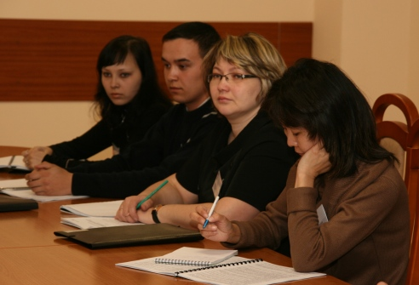 | A meeting of North and Indigenous peoples Committee of Krasnoyarsk Krai’s Legislative Assembly was held on March 25 on the initiative of regional public organization “Information Legal Center of Indigenous Peoples of Krasnoyarsk Krai”. Interns of the training course “Education in the Field of Human Rights and Rights of Indigenous Peoples” took part in the meeting.  Vladimir Surotkin, deputy, member of the North and Indigenous peoples Committee of Legislative Assembly; Vasily Nechaev, chairman of the Education, Science and Culture Committee of Legislative Assembly; Roman Barinov, deputy head of the Public Relations Department of Krasnoyarsk Krai’s governor; Valentina Bokova, head of the North and Support of Indigenous Peoples Agency of Krasnoyarsk Krai; representatives of the Krasnoyarsk Krai’s Ministry of Education and the regional Association of Public Indigenous Organizations of the North of Krasnoyarsk Krai also took part in the meeting.
After a short speech of Lyudmila Magomedova, deputy and member of North and Indigenous Peoples Committee of Legislative Assembly and a presentation of the Center made by its director Elena Nechushkina Valentina Bokova, head of the North and Support of Indigenous Peoples Agency of Krasnoyarsk Krai told about today’s development stage of Krai’ Concept of Sustainable Development of Krasnoyarsk Krai’s Indigenous Peoples and Original Habitat and Traditional Living of Krasnoyarsk Krai’s Indigenous Peoples Protection Act. They also paid attention to the Krai target programme “Small-Numbered Indigenous Peoples of Krasnoyarsk Krai in 2009 – 2011” and North Territories Act.
After the questions of legislation progress in the field of rights of small-numbered indigenous peoples of Krasnoyarsk Krai were discussed interns had an opportunity to ask questions. Sergey Kondiyakov was the first to speak; he described the situation with the closure of school in Pasechnoye Village, Tyukhtet District, and addressed his appeal to V. Bokova and North and Indigenous Peoples Committee of Legislative Assembly of Krasnoyarsk Krai. A representative of the Ministry of Education and Vasily Nechaev, chairman of the Education, Science and Culture Committee of Legislative Assembly spoke on the matter. V. Nechaev took over the control of the matter and promised to discuss the problem of closure of school in Pasechnoye Village at the specially called meeting of the Education, Science and Culture Committee of Legislative Assembly in the presence of the Minister of Education. The representative of the Ministry of Education also promised to help in solution of the problem. Anzhelika Siguney touched upon the issue of late hunting and fishing licenses. One can legally hunt and fish only after the population has migrated to another territory. Vera Kaplina told about the need of teaching native languages. At present teaching native language is less than a quarter of basic rates within the bounds of the regional component. It is natural that teachers cannot make their living only teaching native language; therefore the number of those who want to acquire this profession is decreasing. Those present especially representatives of the Ministry of Education took a keen interest in the matter. Roman Sutlin, student of Krasnoyarsk V. Surikov art school, was interested in non-payment of prescribed student aid to representatives of small-numbered indigenous peoples of the North of Krasnoyarsk Krai. Roman received assurances of payment in the near future. Tatyana Botulu, Yessei Yakut, was interested in denial of benefits: it is noted in the Charter of Evenki Municipal Area that Yessei Yakuts are not small-numbered indigenous people and are equated with Evenks when statute-aided. Yessei Yakuts were deprived of the given benefits after integration of Krasnoyarsk Krai. At present they are trying to decide the issue and restore Yessei Yakuts’ rights on legal grounds. Tatyana Botulu also inquired about state support of communities, difficulties in transportation and distribution of production of indigenous communities.

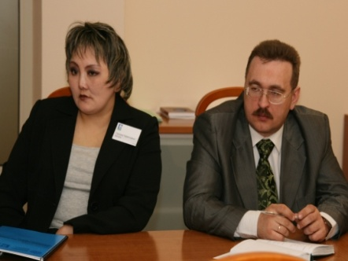 | Many issues were discussed during the meeting, but there was not enough time for many other ones as unsettled questions and problems of indigenous peoples had been accumulated for too long. To continue working on the matter they mutually agreed to carry on interaction between the North and Indigenous Peoples Committee of Legislative Assembly of Krasnoyarsk Krai and the Center.
Interns worked out their own projects aimed to raise funds to solve problems of their community. The project “Iyus Kizhiler” of Yuliya Kondiyakova and Sergey Kondiyakov aiming to preserve the Chulym language was the most interesting one. At present A. Kondiyakov, chairman of the community “Chulym” is working out the first Chulym dictionary and is forming the Chulym script. The worked out project was conductive to that work. The project participated in the grant competition of Endangered Languages Program of Sacred Earth Network (SEN).

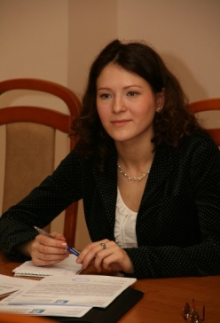 | Elena Nechushkina,  Director of regional public organization “Informational Legal Center of Indigenous Peoples of Krasnoyarsk Krai”

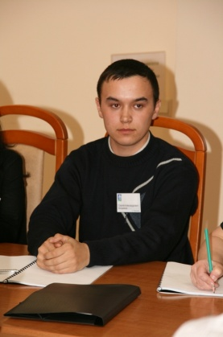 | Sergei Kondiyakov, Chulym  Family community “Chulym”  (Pasechnoye Village ,Tyukhtet District, Krasnoyarsk Krai)

Chulym Problems

I came from Pasechnoye Village (Tyukhtet District, Krasnoyarsk Krai). Our village is situated at the middle course of the River Chulym between Tomsk Oblast and Birilyussy District. Pasechnoye is the place of Chulyms’ compact living. There are only 159 Chulyms in the village and they make most of its population.
Nowadays we have a lot of social problems including heavy unemployment. Apartment houses have not been constructed there since the 1980s that is why young married couples have no place to live. That results in outflow of young specialists as they have no prospects in our village.
Farming is slowly but surely declining. The village board cannot help everyone as they have not enough farming equipment. They even cannot simply help wanting people to hay.
The road to the district center is in a sad state especially in spring. It is always flooded during the spring high water that causes a whole array of problems. The road becomes absolutely worn down in autumn when people begin to gather wild plants and fish intensively. A bus can drive along the road with difficulty. Among other things some Chulyms are unable to process necessary documents such as a hunting licence for example.
And there are a lot of such problems. Although Chulyms live in a place rich in natural resources a small government support is necessary to solve problems. One can harvest wood, raise cattle, fish and gather berries, mushrooms and nuts here and earn quite some money. People are trying not to give up even in difficult times.

About Training Course

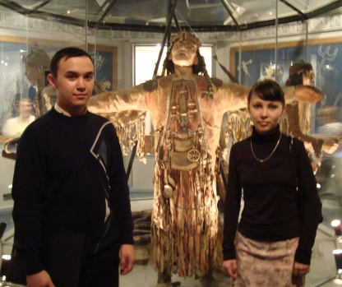 | I am glad to have taken part in this training course as I received valuable information that will help my people to develop. We had a lot of useful meetings where we could even solve some of our problems. This information will help us to do and organize much more. Such things make indigenous peoples progress at a great rate. We have learned good many things about projects and filing of grant applications and that was especially interesting for us. Generally speaking the training course has made a good impression on me.

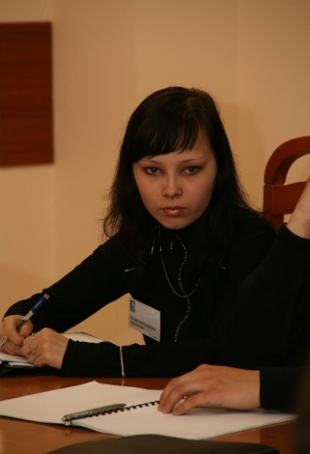 | Yuliya Kondiyakova, Chulym  Family community “Chulym”  (Pasechnoye Village ,Tyukhtet District, Krasnoyarsk Krai)

Today’s Chulyms

I am Yuliya Kondiyakova. I am a Chulym and I live in Pasechnoye Village, Tyukhtet District, Krasnoyarsk Krai. Our village is a place of compact living of Chulyms in Tyukhtet District. It is situated in taiga near rivers, former riverbeds and lakes and this provides us with the staples. In summer we gather berries, mushrooms and nuts. We also fish and hunt.
The villagers sell the catch to send their children to school and other educational institutions. Very few people have fixed incomes. Most of people have a seasonal income. Not everybody return to the native village on leaving schools and graduating from universities. Young married coupled do not want to have children because of absence of steady employment and dwelling.
At present national culture, traditions and language are being revived and developed. A. Kondiyakov, chairman of our community “Chulym” and V. Lemskaya, postgraduate of Tomsk State Teachers’ Training University, are working on the Chulym dictionary. Today there are few native speakers of a Chulym language and all the rest speak Russian. Only grandmothers and some of our parents speak Chulym. Young people want to learn Chulym but the national language circus at school was closed. It is certainly too bad as many adult and little villagers attended it.
Every August we celebrate “Tumpairam” (“Day of Wealth”). We sing national songs and dance during this holiday. We also arrange boat racing and horserace. The villagers decorate their yards and cook festive dishes.
Our costumes are original: hats are made of beads trimmed with fur bands. A dress is white, tight-fitting and full-length with beaded slits on each side. We wear a brown embroidered waistcoat trimmed with fur.

About Training Course

I am happy I could undergo the training course although I had learnt about it shortly before its beginning. I had a vague idea of how the training course would go and where it would get me. But the very first lessons at “Informational Legal Center of Indigenous Peoples of Krasnoyarsk Krai” gave me to understand that the training course would provide me with much new and useful knowledge.
We met many interesting and useful people; we disputed our questions and got answers to many of them. Our sharpest question of closing of Pasechnoye school was settled to a certain degree. We made contacts with specialists and now we can directly communicate with public agents.
M. Sirotinina gave social projecting lessons where she taught us to make correct grant applications. M. Sirotinina gave us many useful pieces of advice and explained us everything we could not understand in social projecting.
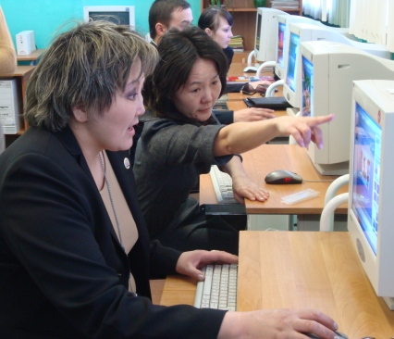 | During the training course we took part in the implementation of the Information Dissemination and Equal Access (IDEA) project in the bounds of the Microsoft Unlimited Potential program of Microsoft Corporation and Project Harmony. At those classes we acquired computer skills in using the ConsultantPlus System, making effective presentations and working on the Internet. These skills will prove useful to me in future. I would like to thank Elena Nechushkina for this training course and explanation of rights of indigenous peoples.

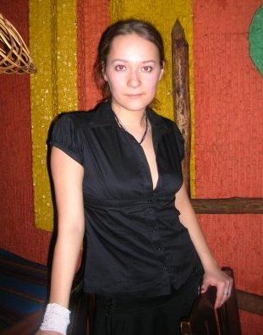 | Lidiya Krivonogova, Khakass  social organization “Trezvaya Sibir” (“Sober Siberia”)  (Krasnoyarsk)

Ethnic Identity of Chulyms at the Present Stage
In 2001 the state legitimated ethic identity of Chulyms for the first time and put them on the official list of small-numbered indigenous peoples of Russia. They were listed as Khakasses before. They live in Teguldet District (Tomsk Oblast) and Tyukhtet District (Krasnoyarsk Krai). Krasnoyarsk Teachers’ Training University conducted ethnographical and ethnosociological research there in 1986, 1996, 2006 using mass survey of almost a hundred per cent of that ethnic group of above-mentioned districts. In 2006 their population on the main ethnic territory was 730 people.
The issue of Chulyms’ ethnic identity and ethnonyms is one of the most complex and important ones. In 1986 Chulyms were still listed as Khakasses but along with that term they used quite a number of other original names such as “Isashnye” (33,8 %), “Chulyms”, “Iius Kizhiler” (11,4 %), “Tatars”, “Tadarlar” (13,0 %), “Pistyn Kizhileri” (7,5 %). Those terms also appeared in various combinations – “Chulym Khakasses”, “Chulym Tatars”, “Prichulym Tatars”, etc. All the terms except “Khakasses” were usually used by elderly people and those ones in the native language (“Iius Kizhi”, “Tadar Kizhi”, “Pistyn Kizhi”) were used only by elderly people because young people do not speak the native language. Only the term “Chulyms” was used by both aged and middle-aged people. Only the official ethnonym “Khakasses” remained to the young people but they tried to avoid it in general.
Ten years later the situation on the River Chulym changed – the growth of national consciousness in the post-Soviet space affected indigenous Chulym people too. National public organizations appeared there for the first time (one in Tyukhtet District and two ones in Teguldet District). If formerly debates about ethnic issues had not been popular then on the contrary many Chulyms discussed keenly the destiny of their nation. At first there were diverse judgments upon further destiny of the nation. Some believed that they should orient to Khakasses and Khakassia. Others was of the opinion that Chulyms are a particular nation and it is necessary to reject the name “Khakasses” and adopt the name “Chulyms” and acquire status of small-numbered indigenous people (Khakasses are not recognized as indigenous by virtue of their number) and make the government assure them rights and support like other small-numbered peoples of Siberia. The revival of nationality showed itself in attitude to ethnonyms. A number of people who recognized ethnonym “Khakasses” reduced in a way and a number of those who recognized ethnonyms “Chulyms” and “Iius Kizhiler” increased. Thereafter supporters of Khakassia gave up the idea and the whole community made up their mind to struggle for status of small-numbered indigenous people “Chulyms”. Administration of Teguldet District favoured the idea and addressed the government a request to assign the district “national” status. The voice of the small people was heard and Chulyms have been included into the list of small-numbered indigenous peoples of Siberia under that title. The transition to a new self-consciousness in Tyukhtet District was unproblematic as local national organization “Sredny Chulym” (‘Middle Chulym”) gave people proper guidance. And a part of indigenous population of Teguldet District suddenly stood up against that renaming. Though they were in the minority (approximately one tenth of the population) they insisted they were put on census papers as “Khakasses” as before. Thus formally 2 “different” peoples appeared in the district. Expedition conducted research three years later when the dust had settled and the new term gradually won there too. At any rate we met only two people who strongly refused to list themselves as Chulyms and wanted to be Khakasses. Thereby one can say almost one hundred per cent of indigenous population accepted the term “Chulyms”. But the previous term still remains and this is natural as such changes do not occur in a flash. However use of the previous term keeps on decreasing. Number of people using the term has decreased from 70.8 per cent to 51.0 per cent during 10 years. As for the rest of ethnonyms 21.8 per cent of people keep on using the term “Isashnye”, 6.7 per cent - “Tatars”, “Tadarlar” and 4.1 per cent - “Pistyn Kizhi”. Only older people use these terms and this number decreases due to natural loss of older population. Young people no longer accept these terms, at times they have not even heard them as they are used only in Chulym language and young people speak only Russian.
In spite of these sharp changes in ethnic destiny of the nation Chulyms’ opinion on relation decree to Khakasses has not practically changed these years. About one tenth of Chulyms suppose Khakasses and they are identical, one third could not define their position on the issue and more than half the population both last year and at present expressed confidence that Chulyms are a particular nation and stand apart from Khakasses.
Thus one can say that nationalism of almost assimilated with Russians ethnos rose after they had been recognized as indigenous people. However ethnic behavior of the nation is being rapidly changing - overwhelming majority of them speak only Russian, national traditions and customs are disappearing, interethnic marriages considerably outnumber mono-ethnic ones.
Chulyms well realize such considerable change of ethnic behavior of the nation despite official recognition of Chulyms. This finds expression in the fact that most Chulyms think there is no future for their nation and that they will completely assimilate with Russians in two or three generations. Only 11.9 per cent of them look ahead optimistically and think that Chulyms will remain, 66.5 per cent think there is no future for the ethnos.

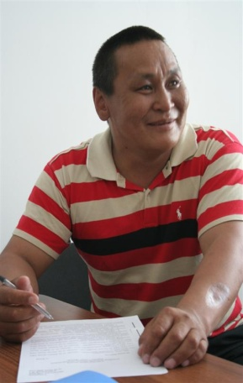 | Aleksander Osogostok, Yessei Yakut  family community of small-numbered indigenous peoples of the North “Kotui”  (Yessei Settlement, Evenki Municipal Area, Krasnoyarsk Krai)

My Native Yessei…

I am from Yessei Settlement which is situated in one of the northernmost parts of Evenkia. Yessei is at three hours out of Tura and an airplane ticket costs as much as the one from Krasnoyarsk to Tura. So sometimes the cost of the ticket exceeds villagers’ wages. What is more there is only one flight a week to the settlement. My family and I fish and hunt wild reindeer and fur-bearing animals. Yessei is practically the only place in Evenkia where wild reindeer come to. Our settlement is by the beautiful Lake of Yessei. It is the place where we fish. Then we make our favourite delicacy “yukola” (dried fish). We take fish to Tura, Krasnoyarsk and sometimes even to Moscow. So we earn our living by trades although we are having hard times – the government practically does not help. And I have to work as I have five daughters and I must proved clothes, tasty food and education for each of them. The proceeds also go to purchase of means of production – nets, cartridges, licences. It is also useful to buy a snowmobile and good guns. One needs all that to realize a good profit. They accept goods low and cost of transportation is high. That is why we cannot hunt and fish in the traditional way but we have to use current technologies.
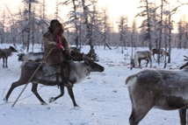 | Telephone communication is bad in the settlement (you can make outgoing calls but no incoming ones). But on the other hand many people have computers and Internet. I do not have good computer skills. It happened that I had to register the community myself – I had to process so many documents! One has to make sense of all of them and go through channels. One could register everything in Tura before and now after integration one need to go to Krasnoyarsk. It is lucky that the Center said it would help me with registration of the community.
.

Tatyana Botulu, Yessei Yakut
family community of small-numbered indigenous peoples of the North “D’ulur”
(Yessei Settlement, Evenki Municipal Area, Krasnoyarsk Krai)

I came to the training course from a distant Evenk settlement of Yessei. Our settlement is unique: particular people - Yessei Yakuts - live only here (about 600 people). All population of the settlement including me believe we are not Yakuts but a peculiar nation different from Yakuts, never mind Evenks. Though our “peculiarity” is not eagerly recognizes by all. Last autumn young ethnographer Sergei Bakhtin came to the settlement to research our national awareness. I hope the research results will show we are a separate people. Of course we have much in common with Yakuts, we understand Dolgans well, but all the same we are distinct from them. These distinctions are a matter of principle for us.
At times of Evenk Autonomous District we had equal rights with Evenks at the District Statute so we could have all benefits and pays that the District’s administration made to Evenks. Now after integration of Krasnoyarsk Krai our status is not determined. We cannot obtain benefits as we did before. I put that question at our meeting with deputies of the Legislative Assembly and I was told that at present they are going into the issue and we will have all the benefits as before. I hope the deputies will keep their promise and they will not drive it to the last minute.
We made an appeal to the Legislative Assembly of Krasnoyarsk Krai and the government of the Russian Federation for recognition of Yessei Yakuts as small-numbered indigenous peoples and our entry into the Common List of Indigenous Small-numbered Peoples of the North, Siberia and the Far East of the Russian Federation several times. But for the present nobody has made any serious answer to our appeals. They say there is little foundation for our special status. We hope first or last we will be recognized as a separate indigenous small-numbered people of the North.
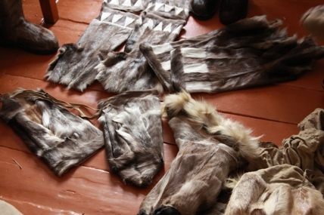 | This year the North and Support of Indigenous Peoples Agency of Krasnoyarsk Krai gives grants for supporting of indigenous small-numbered peoples’ farms. The sum is considerable – one million roubles. It is a very good help to any community. One can buy refrigerating equipment to store fish, snowmobiles to deliver meat and products and many other useful things for trades. We are for this initiative of the Krai’s administration and we also want to take part in gaining grants on a par with others.
I am a chairman of a community, I fish and hunt and I know it is impossible to preserve traditional living of indigenous peoples without good organization of work. It is both work and way of life to us. And I fell hurt when we are regarded only as entrepreneurs and farmers. Hunting and fishing are our way of life and the only way to keep our families. We will become an extinct nation without ability to fish and hunt. What is more at the training course I learnt there is a new order pursuant to which our fishing areas are being put up for auctions. It is impossible just yet to see strangers come to lands that belong to us since olden times and drive us away from our lands insisting they have the right to this. It is nightmare thinking about it. I hope this will never happen. Knowledge of laws will help us. That is why I am glad that I had an opportunity to take the training course and gain more knowledge that will help my community and me to work harder for the welfare of our nation.

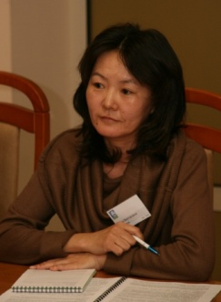 | Vera Kaplina, Evenk  Ethnic Teacher Further Training Center  (Tura Settlement, Evenki Municipal Area, Krasnoyarsk Krai)

Taiga Dweller’s Family

Much regard is paid to upbringing of the younger generation in any culture. They always cared for the children in Evenk families; they took care of the future hunter or the future keeper of the family hearth. Today unfortunately Evenk popular traditions of upbringing are lost. Why do traditional upbringing methods give way to modern ones? I think there are several reasons for that. Breaking up of an Evenk family is one of the chief reasons. What was a basis of a family? Probably each of us should look for the answer in his family.
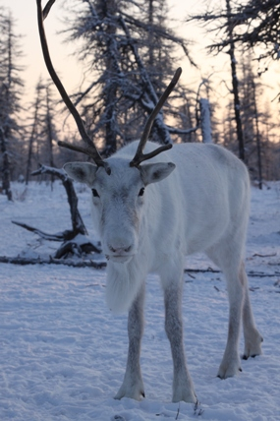 | I am from a large family of ten persons. My brother and I are the youngest. They forgave us many things, elder children did practically everything. So we could only watch, we were never allowed anywhere near serious matters. My only reminiscence of early childhood is silence of the forest. We had to stay alone in the forest for hours when adults went hunting. My brother and I were just little fellows and our mother was busy about the house. Elder children lived in a boarding school and they came only for summer holidays. We had fun then and played rowdy games with them. Our father had a herd of sovkhoz reindeer and some his own ones. They bunched reindeer only when counting and vaccinating. They usually themselves went into the forest and then came back. We were not allowed to come up to them without reasons not to scare them and not to get scared ourselves. That is my reindeer and we were always thoughtful of each other as if watching and weighing up what to expect from each other.

Now psychologists say that northern children get used to isolation and alienation from the rest of the world. This leaves them marked for life. Such way of life causes forming of introversive children’s character. Natural and special environment of an Evenk traditional family live their stamp on development of mind of a small taiga dweller. Most northerners are people of good creative thinking and practical mind dominates. Do not ask if you want to do something, just go ahead and try to do it yourself. How did it come? One has no time for questions and explanations in taiga, and sometimes you are left out on a limb. And there is nobody to ask. And you learn a great deal from your mistakes. And when a child comes to school and begins to receive training within the bound of national programs he finds out he thinks in a special way and he is slow. Creative thinking presupposes different approach to problems solving. Sometimes emotional problems of a child are not the least of the factors. He always has to control his negative feelings and this tension may be long. Rare meetings with relatives in taiga arouse a huge surge of emotions which leads to long talks and detailed discussion of accumulated problems. A long time ago Evenks gathered for sulgans (sulgan – meeting in Evenk) and emotional saturation resulted from rituals: long dances and days-long singing of Uligers. National traditions of psychological aiding still have not been studied well but they are believed to be of high interest to many research people.
An Evenk family is founded upon economic way of life which is mainly based on gathering wild plants. Reindeer quested themselves, they only had to drive a herd and watch weather conditions to better pasture. That is why observation and attentiveness were considered the taiga dweller’s best qualities. Constant change of activities also had an influence on the national character. Monotony of everyday life led to peculiar apathy. We have it from a historical source that Evenks could sit and discuss their problems doing nothing for hours. They took concrete measures after all details of the forthcoming work were clarified. Collective matters were usually settled that way.
Every family submitted to its head and he made critical decisions himself. A modern family has no head at all and nobody has to answer for wellbeing of all members. Among great number of families, there have always been best ones which passed on the best national traditions of upbringing. A taiga dweller’s family is founded upon mutual agreement: if there is no agreement then there is no family and no point in living together. But again family affections based on moral certainty are very strong. Relatives could instantly unite if there is danger and break up when the danger is past. Contractual basis was of paramount importance in many family affairs. Every generation had a particular status: elder members were experts, middle members were organizers and young ones were researchers. Invisible supervision always was there along with seeming freedom whether it concerned fishing or hunting or berrying.
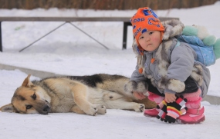 | Rules of conduct were in folk tales of Evenks. If you do the wrong thing, there will be consequences of this. And if you did not know the rules you should guess why you did not get your wish. That is cause and effect must always be clear to everyone. Knowledge of the rules first of all provided security including psychological one.  Modern Evenk families are trying to follow the same rules but today it is so difficult to foretell all developments and many things take place without any reason and one has to live according to different rules.

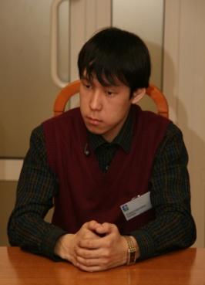 | Roman Sutlin, Selkup  Krasnoyarsk V. Surikov Art School  (Verkhneimbatsk Settlement, Turukhansk District, Krasnoyarsk Krai)

The Way to Creativity

I always liked drawing. Since my childhood I drew my first still lifes and landscapes with a pen, felt-tip pen or in pencil. My passion for drawing did not pass with time but became stronger. After school I entered Krasnoyarsk V. Surikov Art School where I was given the opportunity to fulfill myself as a first-time but professional painter.
I like drawing landscapes most of all. The sun – at dawn, midday heat or washed with rain – will always be the most beautiful image. I derive inspiration from my native nature and this makes me create in the open air rain or shine.
I realized that I want to follow my bent and become a real artist. I will need many efforts besides creative talent to do so. Financial matter is still urgent. Brushes, canvases and paints cost a lot of money but it is impossible to work without them. I have been making some money on the side during all the training. Some day Mark Denisov (then – head of the Public Relations Department) was a great help to me and I am obliged to him beyond all measures. He filed a petition and I was paid an exhibition. Now within the bounds of the target program of indigenous peoples I am receiving an additional scholarship and I can fly home and back free once a year.
Now I am completing my fifth year at the Art School. I want to enter V. Surikov Moscow State Academy Art Institute. This institute as our Art School is named after V. Surikov, great Siberian painter. I hope I will manage to get my plans implemented and enter the institute. The North and Support of Indigenous Peoples Agency of Krasnoyarsk Krai has assisted me in that. The Center has also rendered assistance and I am grateful for everybody’s help.

